SOFTWARE REQUIRENMENT ENGINEERING

Software Requirements Specification Document

For

Electronic Voting/Polling System

Prepared by

Megahertz



**31-December-2015**

Usama Farooq (2340-FBAS/BSSE/F13)

Mudassar Ali Lodhi (2341-FBAS/BSSE/F13)

Irfan Ali (2060-FBAS/BSSE/F13)

Kamran ud Din (2357-FBAS/BSSE/F13)

**Table of Contents**

1. Introduction
   1. Scope of the project
   2. Definitions, Acronyms and Abbreviations
   3. Business Opportunity
   4. Product Statement
   5. Stakeholder Summary
   6. User Summary
   7. User Environment
2. System Features And Requirements
   1. Functional Requirements
   2. Non-Functional Requirements
3. System Analysis
   1. Use Case Diagram
   2. Use case description (brief)
   3. Use case description (detailed)
   4. System Sequence Diagrams
   5. Operational Contracts
   6. Domain/Conceptual Model
   7. Activity Diagram
4. System Design
   1. Collaboration Diagram
   2. Class Diagram
   3. ERD
5. Implementation
   1. Component Diagram
   2. Deployment diagram
6. Conclusion
7. Introduction: This Software Requirement Specification Documents present a detailed description of Electronic Voting System.. It will explain the purpose and features of the system, the interfaces of the system, what the system will do, how it will be implemented, the constraints under which it must operate, how actors will interact with the system. This document is beneficial and is of great importance for both the technical as well as non-technical stakeholder
   1. **Scope:** Electronic voting system (EVS), which will be developed by the Megahertz.

Megahertz will develop this system that interacts with NADRA for identification, verification of voter and for sending result. EVS enables voter to cast the vote Easily, Securely and fairly by using thumb impression. System automate the counting and result generation.

* 1. **Definitions, Acronyms and Abbreviations:**

RO Returning Officer.

NADRA National Database and Registration Authority.  
ECP Election Commission of Pakistan.  
EVS Electronic Voting System.

* 1. **Business Opportunity:**

This project would be replacing the entire manual voting system with Electronic voting system that automates almost all of the electoral procedures. Current voting system is manual and is out dated. It has a lot of problems which leads to rigging in addition to this most of the countries have stopped using manual system and are benefiting from the latest available technology. The new system lets the voters to cast their votes with ease. Voters can cast the votes even from out of allocated constituency.

The new system will bring Pakistan to the leading edge in voting system thus it will be improving the image of country which can lead to different foreign investments.

* 1. **Product Statement:**

|  |  |
| --- | --- |
| **For** | ECP |
| **Who** | Wants to replace the current manual voting system with a better one. |
| **The electronic voting system** | Is a software and hardware product |
| **That** | Enables voter to cast vote securely, fairly and with ease. Result generation is fair and system is highly secure which do not allow any unauthorized access. It also allows the voter to cast vote even if the voter is not present in allocated polling station. |
| **Unlike** | The current manually system which is unreliable and unfair in which voter have to face difficulties in vote casting. |
| **Our product** | Monitor Election process and Coordinates with NADRA and ECP for identification and verification of voter so that voter cast vote only once during the Election process. Which means there is almost no or very less chances of rigging or mismanagement of votes. Our system automates the counting and result generation processes. It uses thumb impression for verification which can be done by using one of the provided interfaces. |

* 1. **Stakeholder Summary:**

|  |  |  |
| --- | --- | --- |
| ***Name*** | ***Description*** | ***Responsibilities*** |
| Megahertz  *Client*  Project Manager    *Architects*  *Designers*  *Sponsors*    *Developers.*  *Concerned organizations* | Organization given a task to build a project. It further consists of its own project managers, designers, developers.  Person chosen by its company as representative for describing of the problem to the developers.  Project Manager is directly concerned with development of the project.  *They are concerned with whole architecture of the system which will describe that how the system will work*  *Designers are concerned with the design of system.*  *Those who are facilitating the System.*  Concerned with conversion of design into system.  *Different organization like NADRA, ECP etc. which will be affected or can be used by the system.* | * Automate the proposed system and make it operational in given time      * Must communicate all the problems and all the features that must be included in the solution/product/software. * Have authority to manage the project by handling responsibility of work performance, organizing and planning. * Make sure that the system is designed in such a way that it can be reliable, fast, and secure and can accommodate changes in requirement at the given time. * Ensure development of correct design, its representation and manages changes in the design. Effectively communicate the design to the other stakeholders * Ensures the provision of enough budget required to develop the system. * Code the system and manages the code in case of design change. * Provide access to the databases for verification of voters, candidates and announcement of final results generated by the system. |

* 1. **User Summary:**

|  |  |  |  |
| --- | --- | --- | --- |
| Voter  *Election*  *Officer* | Person who cast the vote  *Person who will monitor the processing of system at specified* | * Cast vote      * Make sure system is working properly. * At the end of polling transfer the results to the regional | * Server Officer |

* 1. **User Environment**

EVS consist of a machine that is combination of software and hardware. Each polling station have one or more machines depending upon the situation or instructions of Election body. Machine is connected with NADRA. Voter casts the vote by interacting with machine. Machine will verify the voter by communicating with NADRA. At the end of voting/polling it generates the result i.e. declares the winner candidate.

1. **System Features And Requirements:** This section states the features which are to be included in the system as well as some other features which facilitates the working of the system and contributes in ease of usage.
   1. **Functional Requirements:**

* Voter Verification: Verify whether voter belongs to the particular constituency or not
* Vote Casting: Allows the user to cast the vote to their desired candidate.
* Voter Record: It stores record of all the eligible voters of particular constituency. Also Record information of each person voted and to which candidate it voted.
* Candidate Record: Stores all the information of the candidates and number of votes they received.
* Vote Counting: Count the Votes of Each candidate and decide the winner.
  1. **Non-Functional Requirements:**
* Security: Unauthorized person should not be able to access or change the database not even the Server Office (Election Officer).
* Performance: System must be fast enough to enable hundreds of voters cast a vote in a day.
* Candidate Selection Constraint: Each Voter must vote a single candidate.
* Usability: System and its interface must be user friendly. Must contain some error fixing mechanism
* Safety: Must contain a mechanism to backup data in case of power failure or hardware failure so that data may not be lost

1. **System Analysis:** This section describes the functional requirements of the system, interactions between system and the actors. How many actors are there? What type of interaction is taking place?

|  |  |
| --- | --- |
| ACTOR-GOAL LIST | |
| Voter | * Cast vote * Cancel the vote |
| Election officer | * Manage Voters * Manage Candidates * Generate Result |
| NADRA | * Verification |

* 1. **Use Case Diagram:**

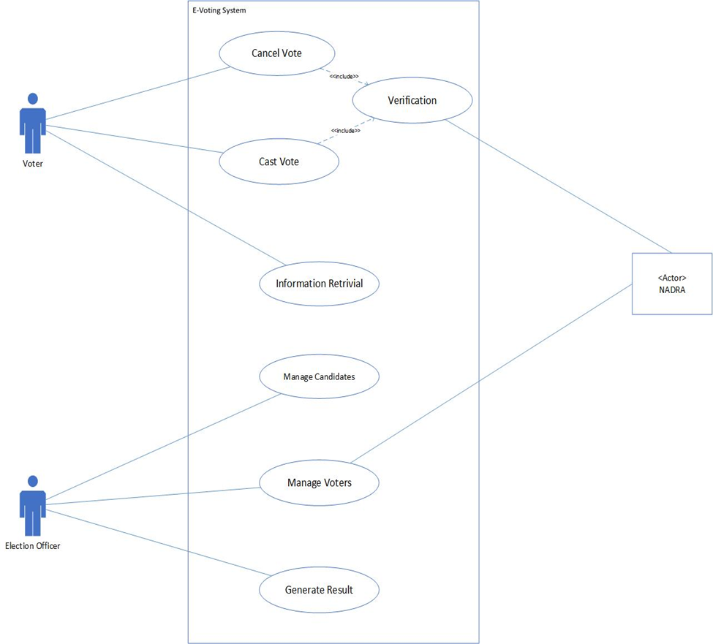

* 1. **Use Cases Description (High Level Use Cases):** This section gives brief overview of all the use cases mentioned in the above diagram

|  |  |
| --- | --- |
| **Cast Vote** | |
| Use case Id | U1 |
| Actor | **Voter** |
| Type | Primary |
| Description | System creates a new E-ballot, copy voter’s data on it and let voter to cast vote to desired candidate. |

|  |  |
| --- | --- |
| **Cancel vote** | |
| Use case id | U2 |
| Actor | **Voter** |
| Type | Optional |
| Description | In case of any mistake by voter during vote casting process, Voter requests to cancel his/her vote after getting verified. |

|  |  |
| --- | --- |
| **Generate Result** | |
| Use case id | U3 |
| Actor | **Election Officer** |
| Type | Secondary |
| Description | At the ending of polling EO directs the system to generate final result, send it to concerned polling station and announce the final result. |

|  |  |
| --- | --- |
| **Verification** | |
| Use case id | U4 |
| Actor | **NADRA** |
| Type | Primary |
| Description | Voter’s Record is verified after voter provides his/her detail required to cast vote. |

|  |  |
| --- | --- |
| **Information Retrieval** | |
| Use case id | U5 |
| Actor | **Voter** |
| Type | Primary |
| Description | Voter requests to get detail of constituency and other voting details etc. |

|  |  |
| --- | --- |
| **Manage Voters** | |
| Use case id | U6 |
| Actor | **Election Officer ,NADRA** |
| Type | Secondary |
| Description | Record of all the eligible voters is saved and managed by the Election officer at the server and in case of any request to update constituency, address or any change in voting detail of voters is received then it will be entertained. |

|  |  |
| --- | --- |
| **Manage Candidates** | |
| Use case id | U7 |
| Actor | **Election Officer** |
| Type | Secondary |
| Description | Candidates will be registered to contest elections in all the constituencies & in case of their name withdrawal, record will be deleted form the list of registered candidates. |

* 1. **Use Cases Description (Essential):**

|  |  |
| --- | --- |
| **Cast Vote (U5)** | |
| Actor | Voter |
| Purpose | Caste the vote and save it. |
| Overview | System creates E-ballot containing the party symbols of the candidates of that polling station. On voter selection of the candidate, system increments the votes and saves the ballot electronically. |
| Type | Primary |
| Pre-Condition | Voter’s Record is already fetched and saved. |
| **Typical Couse of Events** | |
| **Actor Action** | **System Actions** |
| 1**.** Voter Requests To Cast The Vote. | 2. System does   * **Verification (Use Case U4).** |
|  | 3. If Verification is successful, System Identifies The Constituency of The Voter. Creates an E-ballot which has all the party signs of all candidates of that constituency. |
| 4. Voter Selects The Desired Candidate. | 5. System Increments The Votes of the Candidate for which the vote has been casted and saves the ballot. Mark the voter ‘voted’ in the database as to avoid multiple vote casting and show “voting successful” message to the user. |
| **Post Condition:** | E-Ballot Successfully Saved. |
| **Alternative Course of Events:** | |
| **Actor Action** | **System Actions** |
|  | 3. If Verification not Successful , Generate A Message To The Voter That he is not eligible to vote |

|  |  |
| --- | --- |
| **Verification (U4)** | |
| Actor | Voter , NADRA |
| Purpose | Verify the voter whether the voter is exactly the same the individual is pretending to be. |
| Overview | System Verifies The Voter by Using CNIC and Thumb impression as an input which are sent to NADRA for comparison/matching. |
| Type | Primary |
| Pre-Condition | Voter must have selected cast vote or cancel vote option. |
| **Typical Couse of Events** | |
| **Actor Action** | **System Actions** |
|  | 1. System Demands the user to Enter CNIC and thumb impression. |
| 2. Voter Enters CNIC and thumb impression. | 3. System reads CNIC, Thumb Impression And Send it to NADRA. |
| 4. NADRA compares thumb impression received with the thumb impression in the database of NADRA and sends the result to the System. | 5. System Receives the Result and Reads it. |
|  | 6. If Result indicates that the record successfully matched, System Allows the Voter to Vote. |
| **Post condition:** | Creation of Ballot. |
| **Alternative Course of Events:** | |
| **Actor Action** | **System Actions** |
|  | 6. If the result received from NADRA indicates that the CNIC or thumb impression has not matched with those existing in NADRA database.  System shows warning message that the voter is not eligible to vote. |

|  |  |
| --- | --- |
| **Information Retrieval (U5)** | |
| Actor | Voter |
| Purpose | Show Voting Details and Vote Status to the voter. |
| Overview | On Request from Voter, system shows the Voting details of a voter (his/her constituency and eligibility) and his/her vote status. |
| Type | Primary |
| Pre-Condition | Voter data has been fetched and stored in a System. |
| **Typical Couse of Events** | |
| **Actor Action** | **System Actions** |
| 1**.** Voter Requests Vote Information. | 2. System Searches the Record of Voter. |
|  | 3. System Provides Family Number and Details of Voter’s Constituency, Candidates in that Constituency. |
|  | 4. If voter hasn’t casted the vote, system shows its vote status as “not casted yet”. |
| **Post Condition:** | None |
| **Alternative Course of Events:** | |
| **Actor Action** | **System Actions** |
|  | 4. If voter has already casted the vote, system shows its vote status as “Casted”. |

* 1. **System Sequence Diagrams:** 
     1. Cast Vote:

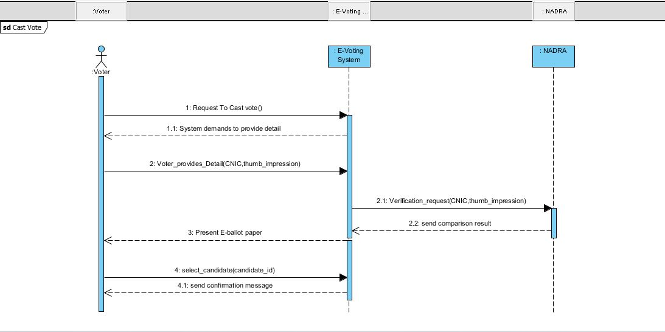

* + 1. **Information Retrieval:**

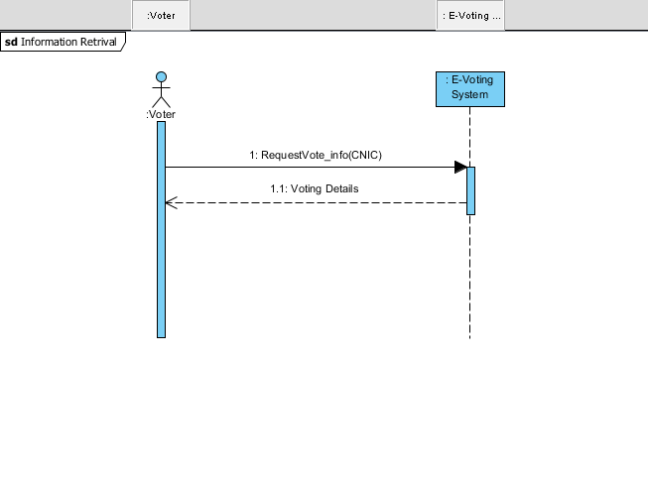

* 1. **Operational Contracts:**

|  |  |
| --- | --- |
| Name | Request To Vote |
| Responsibility | Voter Requests the system to provide voting facility and system demands the Voter to provide details. |
| Type | System |
| Cross Reference | Use Case: Cast Vote |
| Exception | Voter’s Record Not Found. |
| Precondition | Voter V instance must exist. |
| Post Condition | * An Instance of Vote VT was Created . (instance creation) * VT.ISVotingSuccessfull is set to false. (attribute modification). * VT is associated with Voter instance V. |

|  |  |
| --- | --- |
| Name | Voter Provide Details |
| Responsibility | Voter Enters his CNIC and thumb impression which system stores. |
| Type | System |
| Cross Reference | Use Case: Cast Vote |
| Exception | Voter Enters data in unsupported format. |
| Precondition | Vote Casting is underway. |
| Post Condition | * VT.VoterID is modified (attribute modification) * VT.VoterName is modified (attribute modification) |

|  |  |
| --- | --- |
| Name | Verification_Request |
| Responsibility | System Sends verification request to NADRA containing CNIC and Thumb impression. NADRA return the result after matching with the record currently in database. |
| Type | System |
| Cross Reference | Use Case: Verification |
| Exception | None |
| Precondition | Vote Casting is underway.  NADRA is ready to accept requests (isReady attribute is checked) |
| Post Condition | * VT.isVoterVerified is modified (attribute verification). |
| Name | Select candidate |
| Responsibility | Voter selects the desired candidate from E-ballot. System saves the vote and modify the received votes of the candidates and presents the confirmation message to the voter. |
| Type | System |
| Cross Reference | Use Case: Cast Vote |
| Exception | None |
| Precondition | Instance of Candidate C must exist.  E-ballot is presented to the Voter. |
| Post Condition | * C.NoOfVotersRecieved is incremented. (attribute verification) * VT.isVoteSuccessful is set to true(attribute verification). * Vote instance V is associated with Candidate instance C. |

* 1. **Domain/Conceptual Model:** This Section States all the concepts in our system and association between them and the type of association as well.

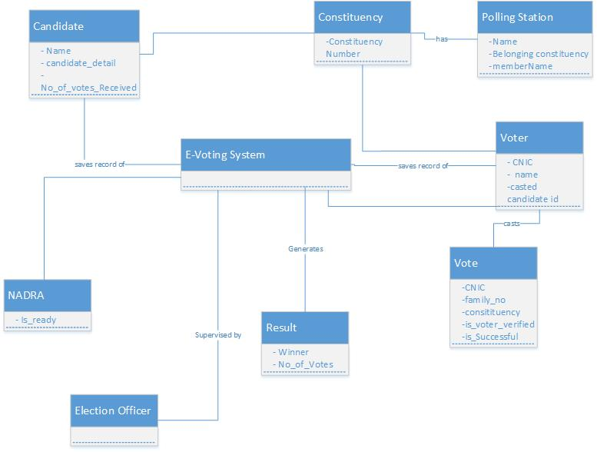

* 1. **Activity Diagrams:** 
     1. Cast Vote:

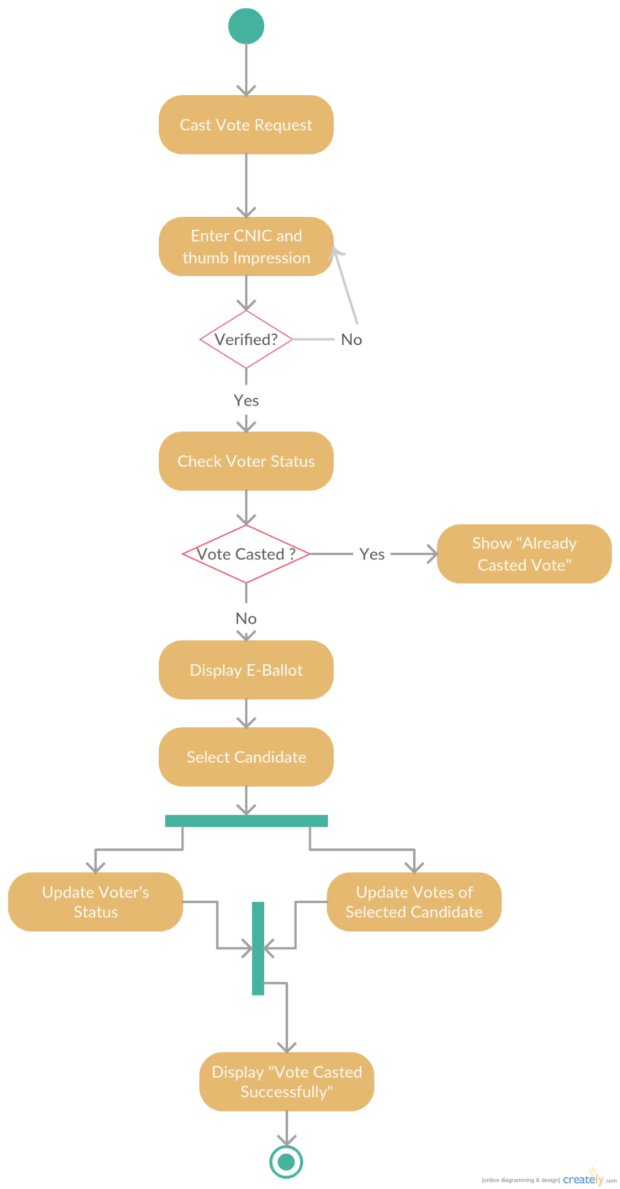

* + 1. **Manage Candidates:**

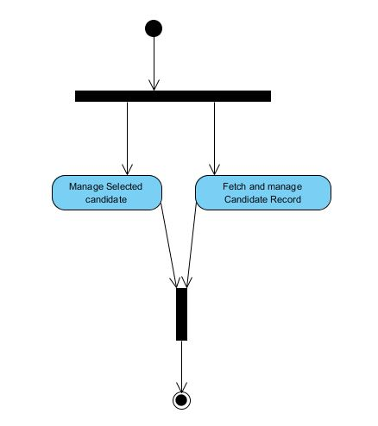

1. **System Design:** This Section include models which represents the logical solution of the problem and on basis of which our project will be built.
   1. **Collaboration Diagram:**

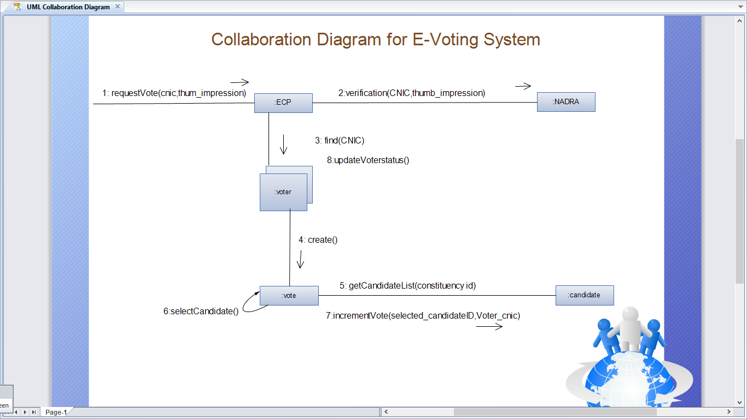

* 1. **Class Diagram:**

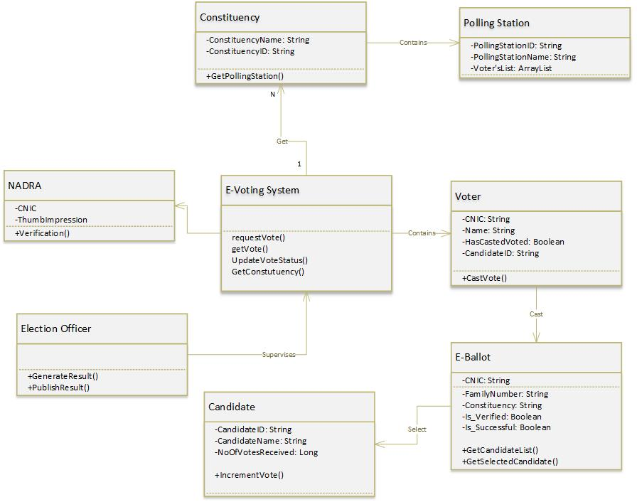

* 1. **ERD:**

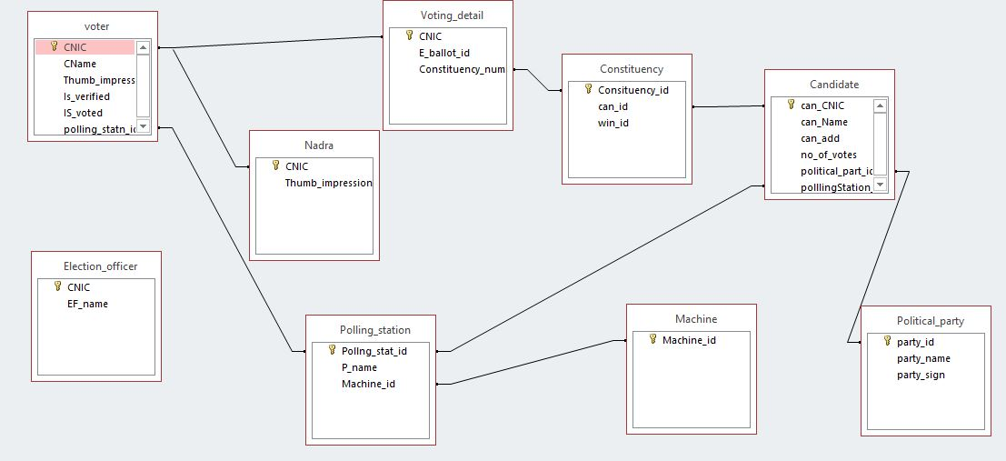

1. **Implementation:** This Section provides details of the components which will be used and integrated to form a solution system as well as details regarding the product deployment
   1. **Component Model:**

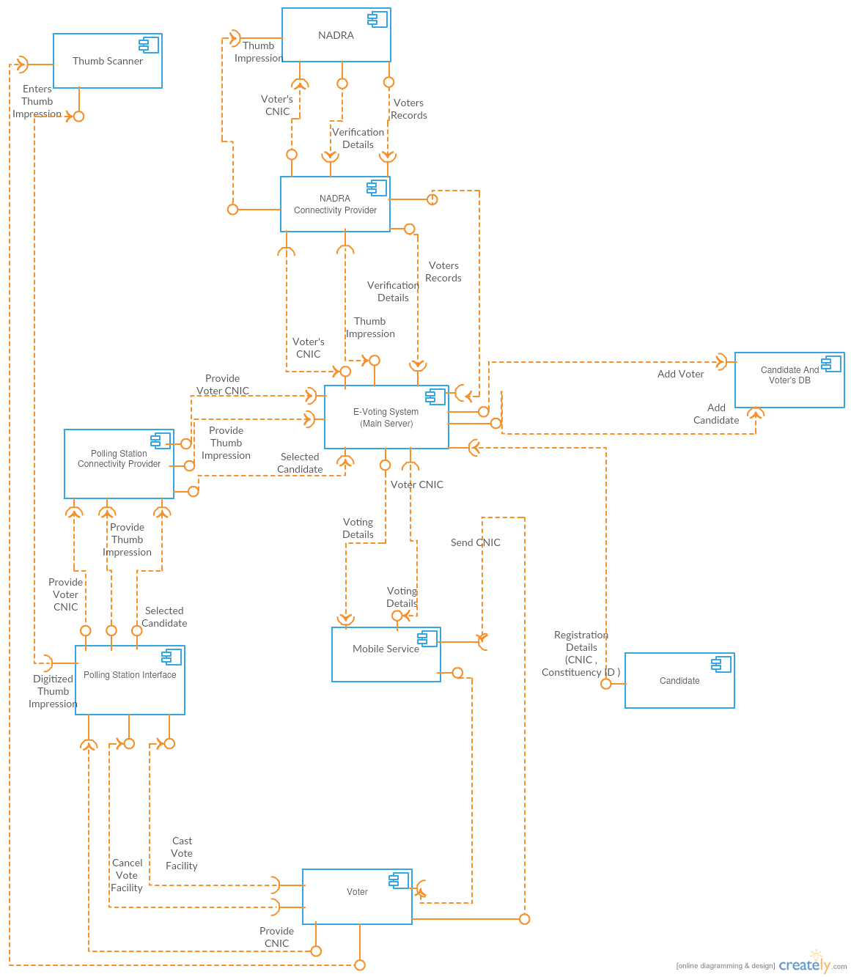

* 1. **Deployment Diagram:**

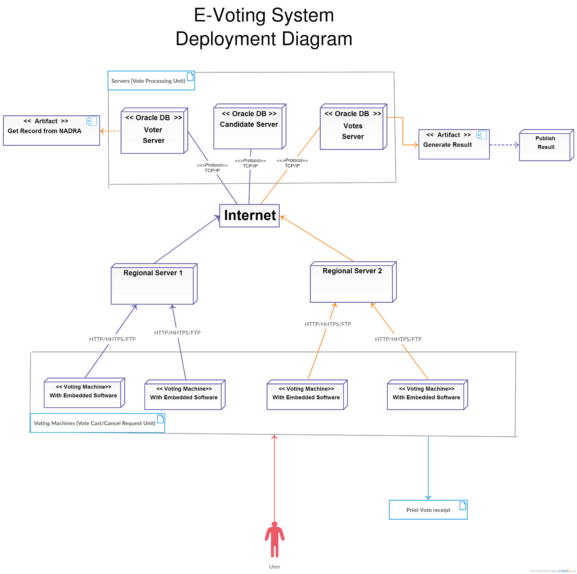

1. **Conclusion:** Hence this document discussed all the functional and nonfunctional requirements, different modeling techniques and explained the requirements according to each stakeholder’s perspective. It is helpful for both the technical and non-technical stakeholders. Analysis, Design and implementation modeling is one of the important contents of this document.